NAPLAN browser loads but doesn't connect

Most common issue is that Wi-Fi is not connected.
- X out of the NAP Locked down browser (Bottom right of the screen, if the Wi-Fi isn't connected a Globe icon will appear )
- Check Wifi connection ( - Bottom right of the task bar - near the clock) is connected.
- Try to make sure  is ticked

Installed but not running

If the NAP Locked down browser looks to be installed (Green Icon on the desktop as above) but isn't loading, you may have tried to launch it too many times.

- Hold ctrl+alt and press delete and select sign out.
- Log back in and try again, be careful not to click it too many times.

Black Screen after NAP Locked down browser closed

Browser may have crashed
Try either
- Hold ctrl+alt and press delete and select sign out.
- Hold ctrl+alt and press delete and select the power button in the bottom right and select Restart.

NAPLAN browser loads but white screen

NAPLAN Browser loads but white screen (after trying more than once)
Browser needs to be uninstalled/repaired. On NAPLAN Test day, send to IT staff, they will be given a loan, IT Staff will fix device so their device is ready for next test.
Uninstall instructions

NAP Locked down browser Uninstall
These steps can only be performed after you have exited the NAP Locked down browser.

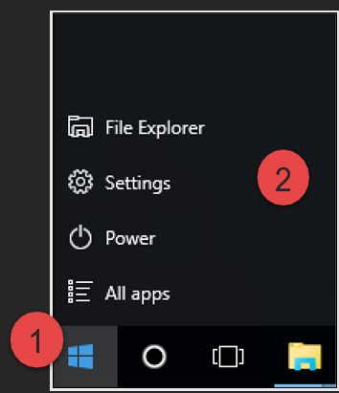
1. Select the Windows icon.
2. Select Settings.

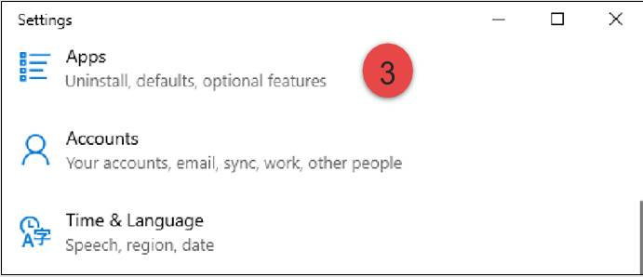
3. Select Apps.

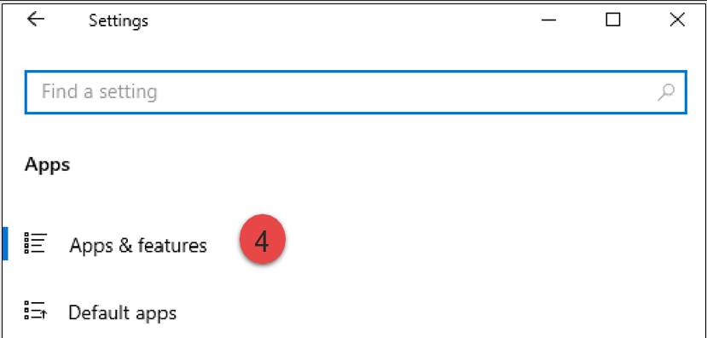

4. Select Apps & features.
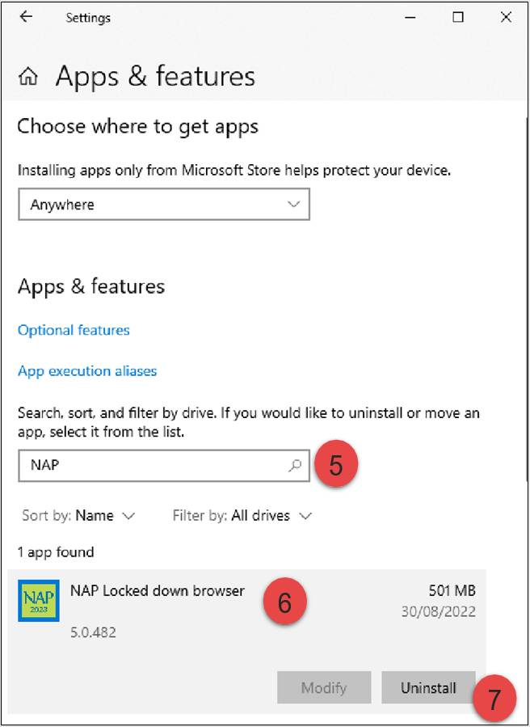
5. Enter NAP.
6. Select NAP Locked down browser.
7. Select Uninstall.

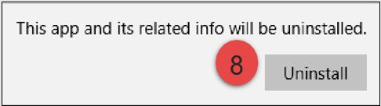
8. Select Uninstall.

If you are presented with another popup asking you to confirm uninstall, select Yes.

NAPLAN 2023 Install

Install NAPLAN Locked down browser
Click here for the download link

Navigate to the locked down browser installer file (NAP Locked down browser.msi) using the operating system’s file explorer. The file will be in the Downloads folder.

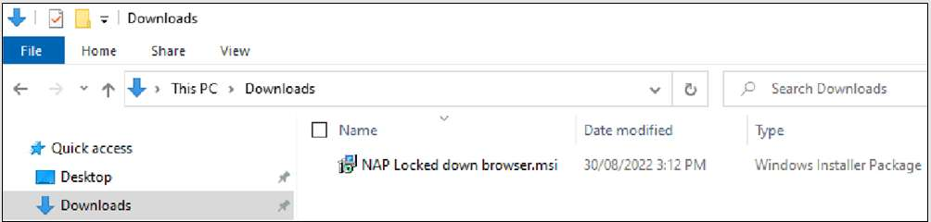
1. Double-click NAP Locked down browser.msi. Depending on you network settings you may encounter some system checks on first installation of the new Locked down browser.

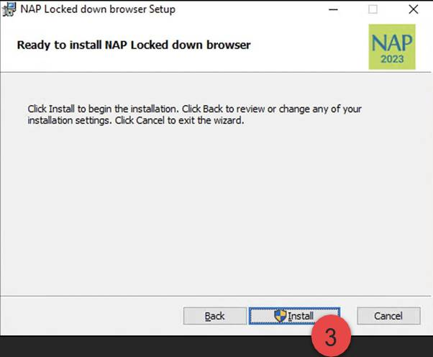
2. Select Next.
3. Select Install.

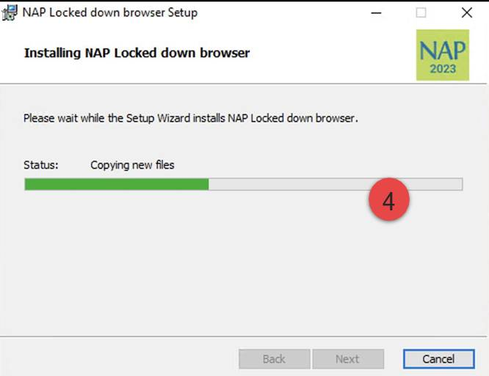
4. Wait for the installation to be completed.

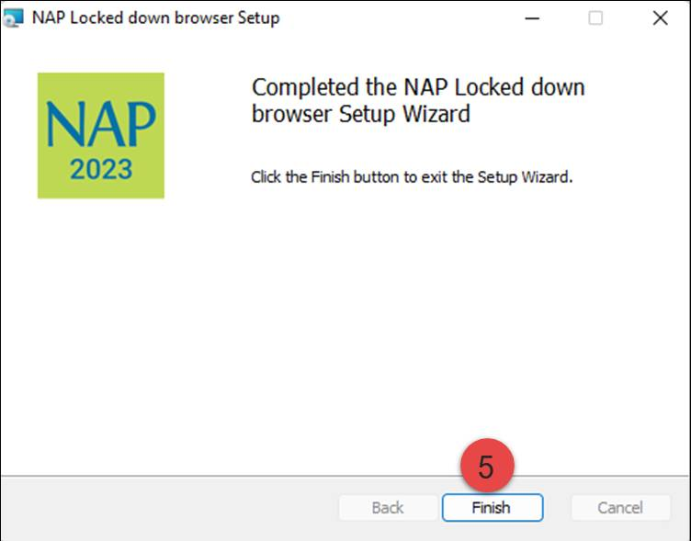
5. When the installer indicates that it has completed the installation, select Finish.

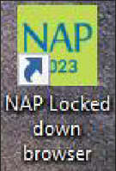
6. Verify that the NAP Locked down browser shortcut is available on the Desktop.

