How to Print Booklet from Konica
printer (Reprographic printer).

- Place the Paper into the copy tray.

- Tag your card and open device functions
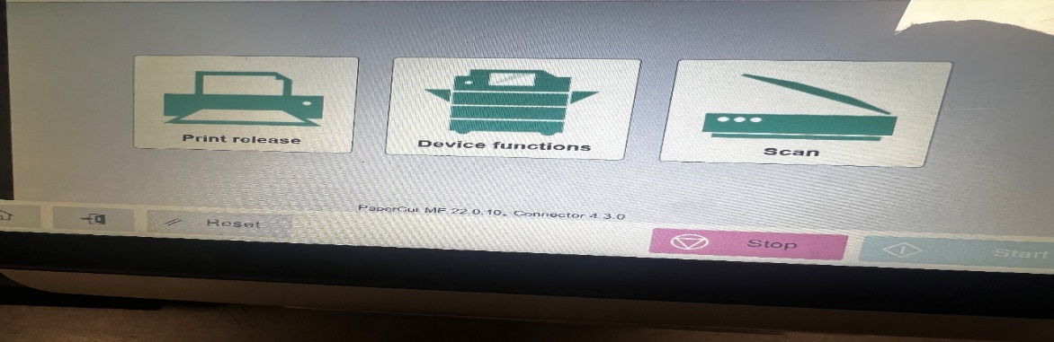
- Choose option copy to copy the pages to Booklet
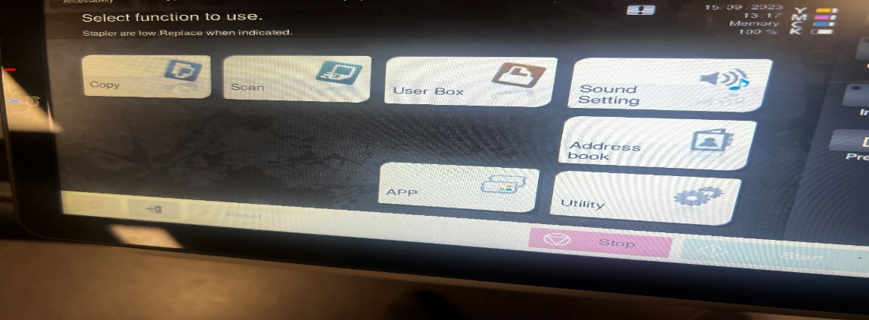
- Choose Finishing option from the screen,
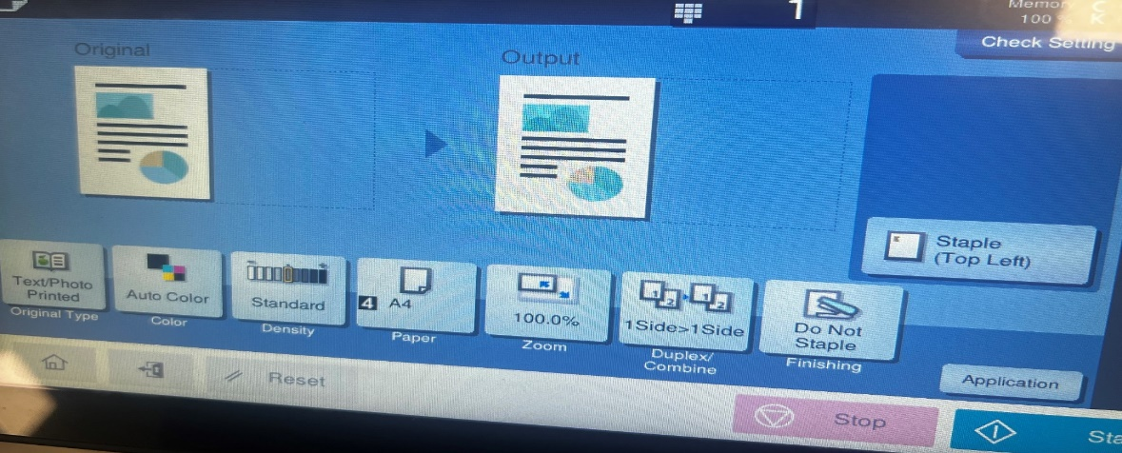

- Choose Fold/Bind option
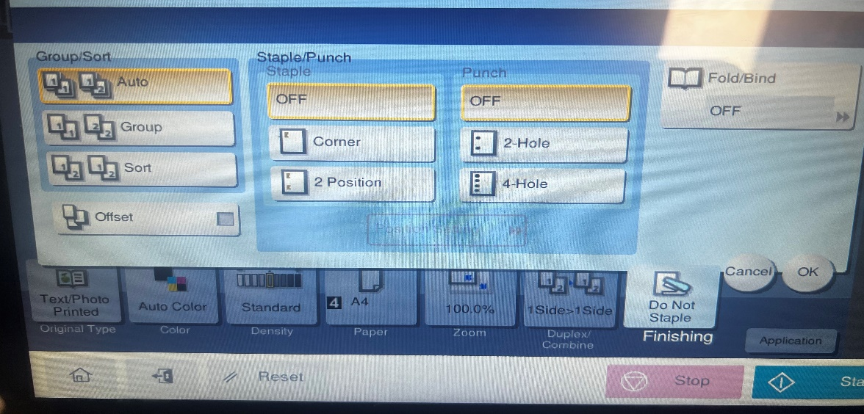
- Choose Centre Staple and Fold
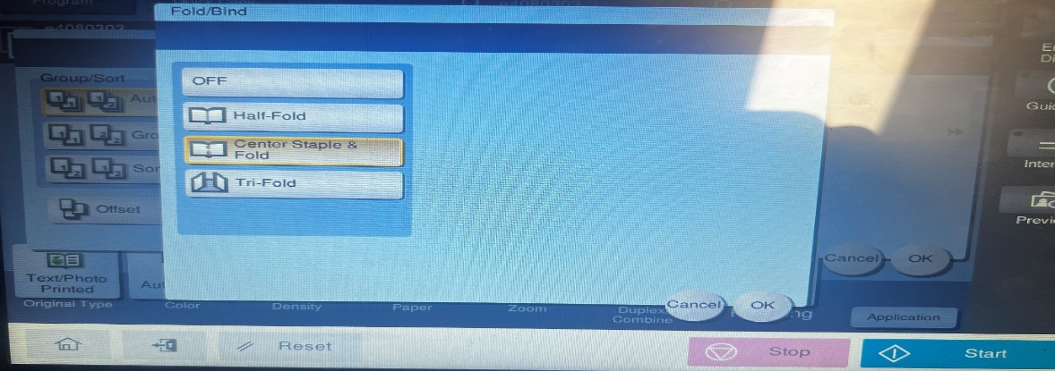
- Choose A3 paper if you want to have a A4 Booklet and choose A4 paper if you want A5 booklet.
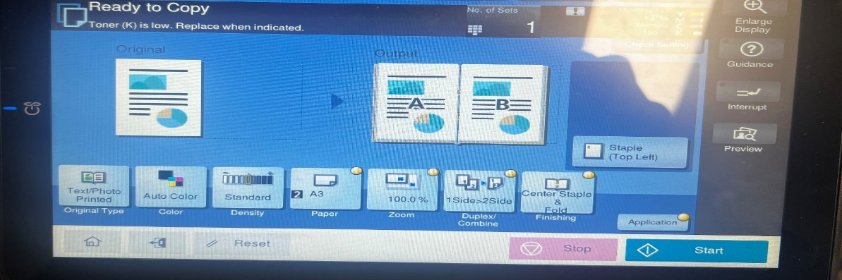
- On the displayed screen, check if the Output is Correct.
- Press start to print the booklets.

Thank you and if you are having issue following the instructions, please contact IT support team.

